Publicity Material – 2023

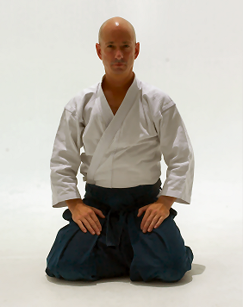
Ethan Monnot Weisgard
6th dan Aikikai
Born 1957 in New Milford, Connecticut.
Resident of Denmark since 1969.

Musician (drummer and percussionist)
Specialized music teacher
Professional Aikido instructor
Japanese Culture Specialist (www.japanbridge.dk)
Senior Tour Guide in Japan (japanpecialist.com)
Author of the book “Bukiwaza – Basic and Advanced Aiki-Ken and Aiki-Jo.”
Ethan Weisgard Sensei was one of the chief instructors in the Copenhagen Aikido Club in Denmark for 27 years, before starting his own dojo, Copenhagen Aiki Shuren Dojo in 2003. He began his Aikido training under Takeji Tomita Sensei in 1976. Tomita Sensei is based in Stockholm Sweden and was a close student of Morihiro Saito Sensei. Saito Sensei was a direct student of the founder of Aikido, Morihei Ueshiba O-Sensei. Saito Sensei studied directly at the founder’s side in the Iwama Dojo for 23 years.

Ethan Weisgard Sensei went to Iwama as uchi-deshi (direct live-in student) for the first time in 1984. At that time there were very few uchi-deshi and he was privileged to receive much attention during his stay there from Saito Sensei. Weisgard Sensei travelled frequently back to study with Saito Sensei, both as uchi-deshi as well as soto-deshi (direct student living close to the dojo).
After Ethan Weisgard Sensei’s first trip to Iwama he started to study Japanese, to be able to understand not only the details and technical points of his teacher, but also to get to know him as a person as well. Saito Sensei shared his knowledge generously, not only in regard to Aikido but in so many other aspects of life as well. He was especially gracious in teaching about Japanese customs, etiquette and traditions.

Ethan Weisgard Sensei was appointed by Saito Sensei to be direct representative of Denmark for the international groups of clubs and dojos throughout the world that trained under his guidance.

Ethan Weisgard Sensei has, from his time with the Copenhagen Aikido Club, acted as interpreter and personal assistant for Saito Sensei at seven international week-long summer camps in Denmark, at seminars throughout Europe and in the Iwama Dojo.
He has also translated for Shigemi Inagaki Sensei and Hiroshi Isoyama Sensei at seminars throughout Europe.

Ethan Weisgard Sensei has taught Aikido in Denmark, Sweden, Italy, Germany, Spain, America, Russia, and even in the homeland of Aikido: Japan. Weisgard Sensei continues to practice and teach intensively and travels frequently, conducting seminars in Europe and America.

